**Encouraging students to learn the language by using the "Scaffolding" strategy of selected classroom management**

**1. Introduction**

Effective classroom management is a crucial component of creating a productive and engaging learning environment. It involves a set of strategies and techniques that empower educators to establish control, promote student learning, and foster a positive classroom atmosphere. By implementing a powerful classroom management strategy, teachers can optimize instructional time, minimize disruptions, and cultivate a community where students feel valued and motivated to succeed.

**1.1 Background**

Language learning is a complex process that requires not only effective teaching methods but also an engaging and supportive classroom environment. In order to encourage students to learn a language successfully, teachers must employ strategies that not only capture their interest but also enhance their language proficiency through effective classroom management. One such powerful strategy that has shown promise in language learning is the scaffolding strategy.

The scaffolding strategy in language teaching focuses on providing appropriate support and guidance to students, helping them develop their language skills in a progressive manner. By offering support tailored to individual students' needs, teachers can effectively facilitate their language learning journey, enabling them to achieve greater success independently. The scaffolding strategy is rooted in the belief that students are capable of achieving significant milestones in language acquisition, given the right support and opportunities.

In a language classroom, the presence of diverse student abilities and backgrounds necessitates a differentiated approach to teaching and learning. Not all students possess the same level of language proficiency, and it is crucial to address this variability to ensure equitable learning opportunities for all. By implementing a powerful classroom management strategy that incorporates scaffolding techniques, teachers can effectively cater to the needs of individual students, fostering their motivation and language development.

**1.2 Significance of the Study**

Moreover, classroom management strategies play a pivotal role in creating a positive and interactive learning environment. Students' interaction and collaboration with their peers have been found to be invaluable resources in language learning. The support and influence of classmates can greatly contribute to students' language acquisition process. Therefore, it is important to design classroom management strategies that not only focus on the teacher-student dynamic but also encourage student-student interaction, promoting a collaborative learning atmosphere.

This study aims to explore the impact of a powerful classroom management strategy, with a specific emphasis on the scaffolding strategy, on students' language learning motivation and proficiency. By considering the characteristics of students' educational levels, the study seeks to design and implement an effective framework that motivates students to actively engage with the language, leveraging their interactions with classmates as a means of language development. By integrating scaffolding techniques within the classroom management framework, the study aims to enhance students' understanding, perception, and usage of the language.

The following sections will focus on the scaffolding strategy, and provide insights into the supportive strategy within the context of lesson study. By examining existing literature and drawing upon research findings, this study aims to shed light on the potential of powerful classroom management strategies, specifically the scaffolding strategy, in fostering student motivation and language learning outcomes.

**The purpose of the study:** to encourage students to learn the language during the lessons held at school.

**1.3 Research objectives:**

* Identifying a powerful classroom management strategy;
* Defining the "Scaffolding" strategy and determining its influence on motivating students to learn the language;
* Encouraging students to learn the language by using the "Scaffolding" strategy of selected classroom management.

**1.4 Research Question**

The study is guided by the following research question: What strategy is effective to use during the lesson to encourage students?

**2. Literature review**

Scaffolding is a teaching strategy that supports students in their learning process by providing them with temporary support and guidance. The concept of scaffolding was first introduced by Jerome Bruner, a cognitive psychologist who emphasized the importance of structure and support in the learning process. Since then, scaffolding has been widely adopted in educational settings, and numerous studies have been conducted to investigate its effectiveness in promoting learning.

One of the key features of scaffolding is that it is temporary, meaning that the support provided is gradually reduced as students become more confident and independent in their learning. This approach helps to prevent students from becoming overly dependent on their teacher or tutor and encourages them to take ownership of their learning.

In a literature review by Rosenshine and Meister (Rosenshine and Meister, 1994), scaffolding was identified as one of the most effective teaching strategies for promoting student learning. The authors noted that effective scaffolding involves breaking down complex tasks into smaller, more manageable steps, providing feedback and guidance as needed, and gradually releasing responsibility to the student.

Another study by Van de Pol, Volman, and Beishuizen (Van de Pol, Volman, and Beishuizen, 2010) investigated the effectiveness of scaffolding in promoting collaborative learning. The authors found that scaffolding was particularly effective in promoting high-quality collaborative learning, as it helped to ensure that all group members were actively engaged and contributing to the task.

Similarly, a study by Wood, Bruner, and Ross (Wood, Bruner, and Ross, 1976) investigated the effectiveness of scaffolding in promoting problem-solving skills. The authors found that scaffolding was effective in helping students to learn how to solve complex problems, as it provided them with the support and guidance they needed to work through the problem-solving process.

Overall, the literature suggests that scaffolding is an effective teaching strategy for promoting learning in a variety of contexts. By providing students with temporary support and guidance, scaffolding helps to ensure that they are able to successfully complete complex tasks and develop the skills they need to become independent learners.

The strategy is based on the work of Russian psychologist Len Vygotsky, whose theories stress the fundamental role of social interaction in cognitive development. He theorized that children learn best when they interact with other people, particularly more knowledgeable people, who provide guidance and encouragement to master new skills.  (weareteachers.com)

If students are losing interest and going off-task as a result of trying, but struggling to complete, a task - offer to help (scaffold) them in completing the task. If you can give them a sense of success and accomplishment by helping them complete the task, this can encourage future on-task behavior (Winderbaum, 2018).

After reviewing the literature, among the methods proposed in the selected technology, the main attention was paid to the "Scaffolding" strategy. Scaffolding means "construction bubbles" in English. As a result, I decided to use Scaffolding as a powerful classroom management strategy to help motivate students to learn a new language. This metaphor was used by J. Bruner and his colleagues proposed to describe the child's learning process in the zone of proximal development (ZPD), that is, "Scaffolding" was chosen because it is a process that allows the student to achieve goals that are located beyond his personal abilities. (J. Bruner, 1970)

**3. Methodology**

The main idea behind scaffolding is to provide students with the support and guidance they need to succeed in language learning.

**Here are some ways to use scaffolding in the classroom to encourage students to learn the language:**

1. Provide clear instructions: When giving instructions or assignments, make sure you are clear and concise. This will help students understand what is expected of them and reduce frustration.
2. Use visual aids: Visual aids such as diagrams, pictures, or videos can be helpful for students who are visual learners. These aids can help students better understand the language and its usage.
3. Break tasks into smaller steps: If you give students a large task, it can be overwhelming. Breaking tasks into smaller steps can help students understand what they need to do and how to do it.
4. Model language use: Use clear and correct language when speaking or writing in front of students. This can help them understand how the language works and how to use it correctly.
5. Provide feedback: Give students feedback on their language use, both positive and constructive. This can help them understand what they are doing well and what they need to work on.
6. Use group work: Group work can be helpful for students to practice their language skills with their peers. It can also help them build confidence in their language use.

In the context of lesson study, the scaffolding strategy refers to the support and guidance provided to students to help them acquire new knowledge and skills. The importance, specificity, and size of scaffolding can vary depending on various factors, including the learning objectives, student needs, and the complexity of the task. Here's a breakdown of these aspects:

**Importance of Scaffolding:**

Scaffolding is essential in promoting effective learning and enabling students to reach their full potential. It provides the necessary support to bridge the gap between the current level of students' understanding and the desired learning outcomes. Scaffolding helps students build on their prior knowledge, develop problem-solving skills, and gradually become independent learners. By providing appropriate support, scaffolding encourages active engagement, boosts confidence, and enhances learning outcomes.

**Specificity of Scaffolding:**

Scaffolding strategies should be tailored to meet the specific needs of individual students or groups. The specificity of scaffolding involves adapting instructional methods, materials, and support to match the students' readiness, abilities, and learning styles. It requires teachers to have a deep understanding of their students' strengths, weaknesses, and prior knowledge. Specific scaffolding strategies can include modeling, guided practice, providing prompts or cues, offering explanations, and breaking down complex tasks into manageable steps. The specificity of scaffolding ensures that students receive the right level of support to maximize their learning progress.

**Size of Scaffolding:**

The size of scaffolding refers to the extent and intensity of support provided to students during the learning process. The appropriate size of scaffolding can vary depending on the complexity of the task, the students' proficiency level, and their progress over time. Initially, when introducing a new concept or skill, a larger amount of scaffolding may be necessary to guide students through the learning process. As students gain understanding and proficiency, the size of scaffolding can be gradually reduced to promote independent learning. This process is often referred to as "fading" the scaffolding. The size of scaffolding should be adjusted flexibly to challenge students while ensuring they have the necessary support to succeed.

According to information, scaffolding is crucial in lesson study to support students' learning. It should be specific to individual needs, taking into account students' abilities and learning styles. The size of scaffolding can vary, with a larger amount of support initially and gradual reduction as students become more proficient. By implementing appropriate and targeted scaffolding strategies, teachers can facilitate effective learning experiences and help students achieve their learning goals.

For the purpose of conducting research work, we had an internship at the «JOO High School Almaty», located in Almaty. The head of the organization Z. Shakirova approved us as our supervisor. 10 "A" grades were selected to do the research with. There are 17 students in the class. The first reason we have chosen this class was that among students with good performance and high level activity, students with average performance in the class were not visible during the lesson. The second reason was to build friendships in the classroom, increase their motivation to study and learn how to work together to help each other. First of all, a research group was formed to conduct a full-fledged research work. During the study, we co-planned the lesson with the study group set up to study the lesson, analyzed teaching and learning, and put our findings on paper. This research work has become an effective pedagogical tool for me and my colleagues to develop our pedagogical knowledge and practice. By using these scaffolding strategies, it is planned that we can create a supportive learning environment that encourages students to learn the language. At the same time, we decided to emphasize patience and flexibility, because we also know that each student learns at his own pace.

In this regard, it was assumed that the chosen strategy should give its results, as it is believed that the students' enthusiasm for the lesson increases during the lesson with the help of the teacher and the students of the class.

**4. Planning, Results and Discussion**

**4.1 Planning, Results and Discussion of 1st LS**

Research participants who participated in the process of planning of lessons on Lesson Study:

1. Marita Snabekova

2. Kairova Kuanysh

3. Aidaraly Mereke

4. Talkanbayeva Kadirgul

At the first meeting of the Lesson Study group, the course of research work was planned. The course of research was decided to consist of 3 cycles of one month.

1) "Survive the drive", 10:40-12:05, classroom 306

2) "Changing lives", 10:40-12:05, classroom 306

3) "Spending money", 10:40-12:05, classroom 306

If the research result could not be reached within this interval, one more cycle was considered.

The members of the Lesson Study group met and familiarized themselves with the progress of the first study lesson, discussed the methods used during the lesson, and unanimously approved the methods at the stages of the task that were deemed necessary. Notified that excess materials were planned, removed and made changes to the plan *(Appendix 2)*.

In addition, descriptors and evaluation criteria were created for each task, and students were evaluated using those criteria.

The scaffolding strategy in research sessions was carried out in 3 steps:

- I do;

- we do;

- you do.

Names of students to be studied by the LS team:

Level A

Level B

Level C

**The topic of the 1st lesson:** "Survive the drive".

**The purpose of the 1st lesson:** use speaking or writing as a means of thinking and exploring a range of different traffic rules; reading a research report and developing a scientific vocabulary on a specific topic.

**Various data used in the lesson:** photos, figures, text data, etc.

First of all, the lesson begins with the "Tongue Break" exercise, taking into account that the students come after the algebra lesson, in order to refresh the students and introduce them to the atmosphere of the English language subject. I created an atmosphere of a lesson in English for the "Language breaking” exercise. After the organization stage of the lesson, in order to open up the topic, I supported students’ critical thinking and asked stimulating questions. Then I divided them into groups according to the types of transport, and the division into groups was closely related to the new topic. The students were well trained in the methodology used during the practice, during the homework check, they changed their notebooks, checked each other with the correct answers on the board, and actively participated in the Quiz competition on the topic of the previous lesson. Students who answered correctly during the task were evaluated with points.

I introduced students to new words on a new topic, and in order to further use new words in practice, I conducted group work with students, where students continued their work by dividing their roles (speaker, secretary, artist, data processor). During the group work, I used the Scaffolding strategy in order to increase students’ enthusiasm for the language. The “tarsia” method was used for new words. In the task “Combining words and word meanings”, students helped each other by constructing a specially given figure shown by the teacher. Later, he expressed his thoughts on the question. At this point, I noticed that the students began to develop responsibility for learning and leadership qualities.

The next group work was on the correct sounding of the words and the students worked together to fill in the willow leaves using the given sound symbols.

According to the reading task, each student individually read the text “What’s the fastest way to get across London?”. After the end of the time given for reading the text, I determined how well the students understood the text using the “Jeopardy labs” website by asking special questions. While listening to the given answers, I realized that the students understood the given text to some extent.

Before moving on to the next grammar task, I played the game “Improve the memory” to refresh the students and improve their memory. During the game, students of the class fully participated and showed their interest.

Later, the grammar topic “Comparatives and superlatives” was introduced, and the task “Fill in the blanks” was performed with the students. It can be concluded that the students performed this task easily and quickly, and compared to that, they understood the grammatical material presented in the neiw lesson.

I concluded my first lesson on LS through the game “Find the picture” given by asking a special question to confirm the lesson. At the end of the lesson, new grammar exercises were given for homework, and each student was evaluated according to the Lollipop method, based on the points they earned during the lesson. Students filled out their thoughts on the lesson on a special card and sent it to my mobile phone (photo of a mobile phone) shown on the board *(Appendix 2)*.

3 students selected from 10 “A” classes were observed for joint research work on “Lesson Study”. Now, the teachers who participated in the study of the activities of students A, B, C, carefully observed each activity. During the research lesson, the leader of the diploma project, the English teacher Marita Snabekova supervised the high-achieving “A” student. Student “B” was supervised by trainee coach Aidaraly Mereke, while Kairova Kuanysh was supervised by student “C”. Students A and C were randomly in the same group during grouping. In the group, the student A in the group had a great influence on the activity of the student C in performing the tasks given during the lesson.

In the 1st study lesson, I used the “tarsia” method in performing the task on new words. First of all, I introduced the students with new words on the topic and showed a picture of the figure to help the students in completing the given task. Later, students helped each other to find the word and its meanings using specially given figure parts. Then I asked CCQ questions to students who were not very active. Students individually expressed their thoughts on the questions *(Appendix 2)*.

After the end of the 1st lesson, a questionnaire consisting of 3 questions was received from the students.

**Questionnaire questions developed within the LS problem:**

- Which part of the lesson do you remember in particular?

- What prevented you from freely expressing your thoughts during the lesson?

- How effective is it for you to work together with other students of the class?

***Diagram 1: Results of questionnaire №1***

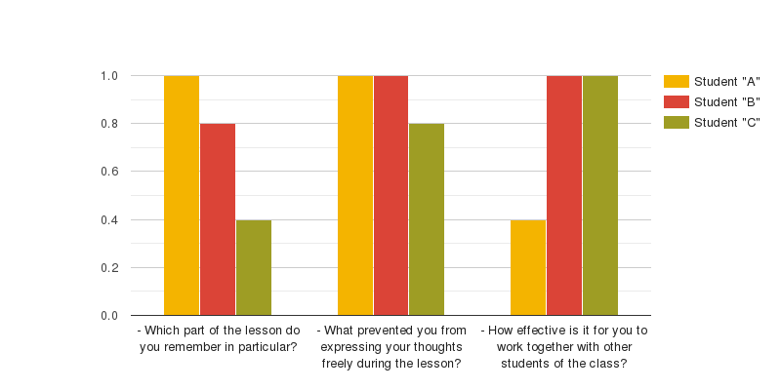

According to the results of the questionnaire received after the 1st lesson, to the question of which part of the lesson did you remember in particular, student A answered the question of group work, text work questions and assessment through the “Jeopardy labs” site; Student B answered group work, “Find the picture” game, student C answered text work and “Find the picture”, “Improvement” games. The next question asked “What prevented you from freely expressing your thoughts during the lesson?” Students A and B answered that they did not encounter any difficulties and obstacles, while student C answered that my thoughts were scattered and that I had little knowledge on the subject. According to the last question, students A, B, C answered that they are very good, they save time, they try to be the first to finish the given task quickly while competing with other groups. In fact, it is necessary to constantly involve the student in organizational and leadership oriented classes and activities*.*

Student A, Arslan, was not very active in this lesson, but he was able to complete the task he set before him, and he was able to demonstrate his knowledge in comparison with the students in the group. In addition, I noticed that Akylbek, student B, was not very active in this lesson, as I expected, compared to the previous lessons. The fact that the student could not be active in the whole class seemed to have made a mistake in the group. Because in this group, “B” level students sat side by side, there was no competitive study in the group, they worked at an average level. Although the observed student worked with the group, he was not very active. C-level student Aknur’s knowledge, skills, and abilities were unstable, he did not take much responsibility in group work, but he tried to fully answer the questions with the help of the group.

In conclusion, during the lesson, students A and B did not have any serious problems, and I noticed that student C had a little trouble expressing his thoughts freely in oral tasks. For this, I understood that student C needs to gather extensive information on the topic and work with more vocabulary and grammar rules.

Students B and C noted that such tasks are useful for them, that is, they help to remember the information they have received and help to save time.

During the lesson, student A was able to help other students in the class because he knew the subject very well and was at a higher level among the students in the class. But this situation seemed to slow down his activity. In the next lessons, I intended to focus on this problem, I marked it as a situation that needed to be solved.

Lesson Study group members gathered and reviewed the results of the first study lesson. In the Snabekova Marita’s analysis of the lesson, it was said that although the student “A” was not very active in the group, he successfully completed all the tasks assigned to him, his leadership qualities were observed in the internal work of the group, he helped the students of the group, and he was able to demonstrate his knowledge.

In the Aidaraly Mereke’s analysis, the student “B” was told that although he was ahead of other students in group work, his activity was not very strong, his language skills were developed well, and he correctly accepted the criticism given during the assessment.

Kairova Kuanysh, C student’s observer, said that according to the results of her analysis, she did not feel much responsibility in group work, but she was able to work at a better level than we thought. In the class, he had a little difficulty in answering the questions asked individually, and the student was uncomfortable in being free, and with the help of the group students, he tried to express his thoughts freely, understanding the question asked.

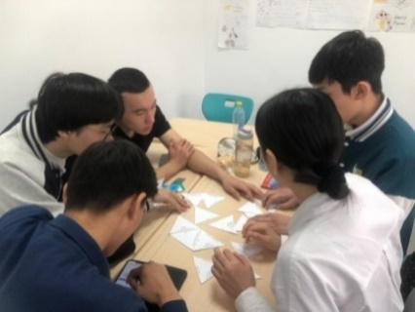 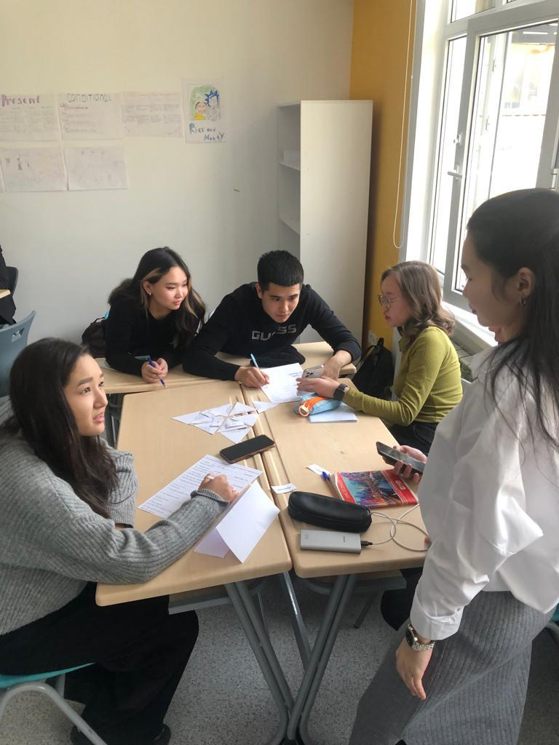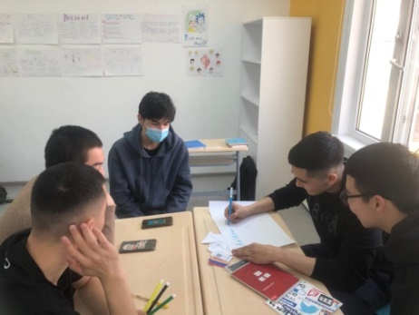 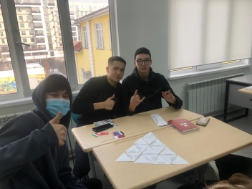 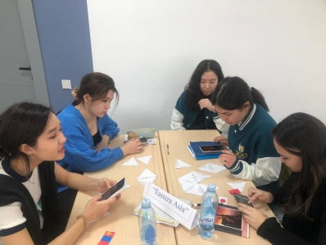

**4.2 Planning, Results and Discussion of 2nd LS**

The members of the Lesson Study group gathered, got acquainted with the plan of the 2nd lesson and focused on the tasks to be performed according to the learning goals. In this cycle, the activities recommended by Pete Dudley's manual (joint planning, segregation of supervised students, etc.) were fully implemented. First of all, the methods used during the lesson were discussed, and the methods at the stages of the task were unanimously approved. In addition, descriptors and evaluation criteria were created for each task, and students were evaluated using those criteria. During the lesson, it was planned to use "Class Coupons" cards in order to increase students' enthusiasm for the lesson *(Appendix 2.1).*

**The topic of the planned lesson:** "Changing lives".

**The purpose of the planned lesson:** to learn to create sentences according to the rules of Present perfect and Present perfect continuous; Improving vocabulary during the formation of speaking skills by focusing on strong adjectives.

**Various data used in the lesson:** photos, worksheets, text data, snowflakes, etc.

The first part of the lesson, as usual, began with the "Tongue Break" exercise. "Tongue breaking" exercise "How do you spell your name?" I got the training. This will increase students' interest in the lesson, help them to find the letters correctly, as well as help them work quickly during the lesson and create an atmosphere of English. Group work. From the new words given to the house, a task was obtained from the topic "Modern families" using the "Mega brain" method. According to the meanings shown on the board, students need to fill the cerebral cortex with new words. The students completed the given task individually.

In order to open up a new topic and form an understanding, the listening task "Program about the charity Adelante Africa" was listened to and special questions were asked. Students shared their thoughts on the questions. The new words of the lesson were "Strong adjectives". Work with new words was carried out according to the Scaffolding strategy. According to the "I do" step, students were fully introduced to new words and an explanation was made. In the "We do" step, through the "Complete the sentences" task, students performed the given task together, expressing their thoughts. Performed personal work in the "You do" step. Replaced normal adjectives with strong adjectives. Student activity was exceptional and high.

The grammar topic of the lesson was "present perfect/ present perfect continuous + for/since". Students reminded each other of the topic and gave examples of tense formulas. Later, he performed the exercise "Fill in the blanks" individually. In the middle of the lesson, the game "Two truths and one lie" was played to refresh the students. The condition of the game: to find the false one among the 3 pieces of information given by the student. Pupils make 3 sentences using the grammatical topics learned in the new lesson. 2 of the sentences were true information and 1 was false information. Through the game, students were able to consolidate their knowledge and think in terms of logical criticism.

At the end of the lesson, he worked out today's topic. Confirmation questions followed the "Snow balls" method. They verbally answered various questions on the topic of charity by sending snow tires to each other. Students were collecting points for each completed tasks and activities. During the lesson, they had to fill in a picture of a clock without numbers. In addition, students who answered the questions correctly during the lesson and showed special activity received class coupons. There were various activities and bonus points. Some students used their chosen coupons during this lesson, while others saved them for future lessons. Class coupons were very interesting for students, they could arouse their interest in studying, learning and being active. And at the end of the lesson, he was able to write down his thoughts, successes and difficult points in a specially provided google document *(Appendix 2.1)*.

**Interview questions developed for 2nd lesson study within the LS problem:**

- What kind of work was effective for you during the lesson?

- Were you able to help your classmates while completing assignments in class?

- What was the help of your classmates during the completion of the assigned tasks and achieving results?

***Diagram 2: Results of questionnaire №2***

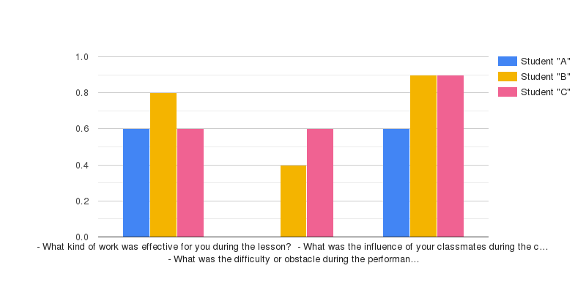

At the end of the lesson, students were interviewed with 3 questions. Arslan, student "A" in the control work, said during the lesson that he particularly liked the homework received by the "Mega brain" method, the 3-step types of work implemented by the Scaffolding strategy, and the game “Two truths and one lie”. In addition, he said that there were no problems during the lesson, he was able to freely share his thoughts and help his classmates. He said that he was able to awaken his qualities of respect, respect, and peace through the work done by sharing thoughts with his classmates. In fact, Arslan liked to do individual work, but through regular collaborative work, he was able to establish friendships with his classmates*.*

For Akylbek, while the Megamind homework, the 3-step activities, and the pronunciation task answered orally using Snowballs were effective, he said he experienced small problems with the creation of a complete complex sentence in the game "Two truths and one lie" in terms of grammar rules. However, he said that he was able to help other students in the class, and thanks to the help, his activity in the lesson increased. And since Akylbek is a very open, very active, energetic student, he said that he liked the work he did with his classmates and that it had a special impact on language learning*.*

Aknur said that the 3-step activities and the “Two truths and one lie” game were effective in class and he had no problems. It turned out that Aknur had a great influence of classmates while completing assignments and expressing his thoughts. Indeed, it was observed that student "C", with the help of his classmates, completed the tasks slightly above the expected result.

The members of the Lesson study group collected and analyzed the results of the lesson after the 2nd study session. Answers were given to questions about the progress made by the student, whether it was sufficient, what results the student achieved in comparison with other students, whether the implemented methodology helped or hindered the child, were there any surprises.

According to Marita Snabekova’s observation sheet, analyses shows that student "A" was very active, shared his thoughts with his classmates, as usual, he perfectly completed all the tasks assigned to him, and he managed to demonstrate his knowledge.

Student "B" Aydaraly Mereke, during the analysis, noted that he had slight difficulties in completing the task according to the rules of grammar in individual work, but he was able to show his activity compared to the last lesson, and when performing an individual task, he emphasized that some of class worked in competition with classmates of the same level. He suggested that competition is necessary for success in language learning.

During the lesson, a C-level student said that under the guidance of Kairova Kuanysh, she felt more responsible than in the previous lesson, was able to complete the grammar task at a higher level than we thought in individual work, and that she was able to overcome difficulties with oral answers questions in the classroom due to the influence of the teacher. That is, he can set tasks for pronunciation with the teacher’s help or the students’ advice.

During the lesson, there was not enough time for a full assessment and conclusion. Supervising teachers warned that the next lesson should reduce the number of tasks and pay attention to assessment.

During the lesson, it was found that the C-level student who was observed performed slightly above the expected result when analyzing the results of work with samples. This can be explained, firstly, by the fact that the pronunciation skills of this student still need to be worked on, and secondly, by the ability to use the knowledge gained in the previous lesson.

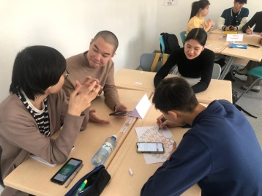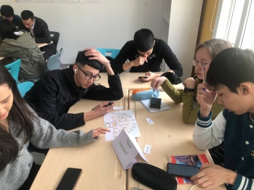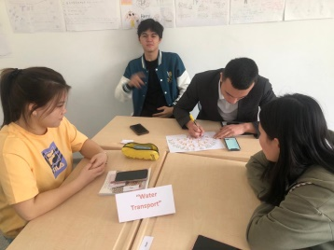

**4.3 Planning, Results and Discussion of 3rd LS**

**06.03.2023** At the last meeting of the Lesson Study group, he reviewed the results of the research lessons conducted so far and planned the 3rd lesson plan for the last cycle together. He chose teaching methods to achieve results in accordance with the topic and selected educational goals. LS guidelines were used in the planning process. Accordingly, the number and type of tasks to be performed in accordance with the educational goals were determined. Descriptors and evaluation criteria were created for each task, and students were evaluated using those criteria. And specific goals that the student needs to achieve have been determined. In the previous 1st lesson, students were warned that they were not correctly divided into groups, and changes were made to the grouping plan *(Appendix 2.2)*.

**The topic of the planned lesson:** "Spending money".

**The purpose of the planned lesson:** based on specific information, the topics of the lesson will be discussed; understands and applies evidence across a wide range of familiar topics in general and across the curriculum, including some advanced grammar.

**Various materials used in the lesson:** posters, maps, photos, etc.

It started with the usual tongue twister exercise to create an English atmosphere. A work was selected for the exercise without misleading. Misleading is one of the most unique and effective language breaking exercises. Increases students' interest in the lesson, easily trains their language so that they can speak English. Homework "How sensitive am I?" essay work checked. Students read a short essay about themselves.

Further, in order to reveal the topic, the students answered the questions and were divided into 3 groups using money coupons. He got acquainted with the new words of the topic "Spending money". Answered the questions about the new word orally and fulfilled the "True or false" task.

In the next task, it was necessary to defend a poster for group work. First of all, according to the 1st step, the students got acquainted with the diagram with the percentage indicator. Further, the students actively worked together to defend and prove their topics through posters on the topics given to them. Students got acquainted with the "Golden Rule" in group work. After the allotted time, the students defended together with the group. During the defense, "A" and "B" level students spoke for a long time, "C" level students spoke less. CCQ questions were asked to check their understanding and summarize the group work. As a result, students were able to give complete and specific answers.

The lesson continued with the grammatical rules of Compound nouns/present perfect/past simple. Pupils shared what they knew, remembered the formulas of the tenses, and were able to name complex nouns. And he performed grammar tasks individually. According to the given, students had to find and match pairs of complex nouns. "Improve the memory" game was held after the task to refresh students and improve their memory. During the game, students of the class fully participated and showed their interest.

After that, each group was given the same number of exercises on a new grammar topic, but with different tasks. All students in the group participated in the exercise and performed the task in turn, sharing their thoughts.

At the end of the lesson, to confirm the topic, "Who is the faster?" the game was played. Cards with special simple verbs were taken for conclusion. Students composed complete sentences according to the topic based on the selected simple verb.

During the lesson, students were evaluated by the "Lollipop" method for each task. And at the end of the lesson, they wrote down their thoughts and comments about the lesson on a special paper and sent it to the teacher's mobile phone (mobile phone photo) *(Appendix 2.2)*.

**Interview questions developed for 3rd lesson study within the LS problem:**

- Did you like the lesson? If "yes" what is the point, if "no" why?

- What was the help in overcoming the obstacles encountered in the new lesson?

- Were you able to work together with your classmates during group work? What was your position in the group: giving or receiving help?

***Diagram 3: Results of questionnaire №3***

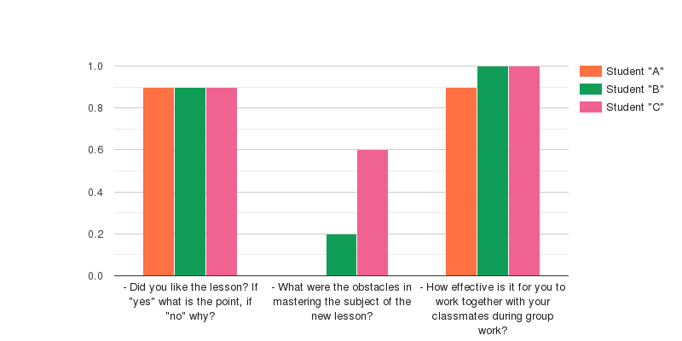

Student A said that he liked the course of the lesson, including defending poster through group work, grammar tasks. In addition, during the new lesson, he said that the teacher's words on the topic and a special diagram were a special tool in performing the task, and thus there were no problems during the task, and he also shared his thoughts about group work. According to him, he considers himself an introvert and does not like working with many people. However, he emphasized that he gains confidence and responsibility during group work, he likes to share his thoughts with other people, and he can evaluate himself while sharing his knowledge with other people.

Student B answered: "I liked the lesson, I got a lot of information." But when I asked why you didn't try to answer during the poster defense, he said that I thought I would answer the questions if my other classmates wanted to participate. During the new lesson, he said that he had a little trouble with grammar tasks. He gave several examples for understanding and said that the task should be completed. In addition, he said that it is effective to work in a group with the students of the class, he can easily analyze the topic by asking other students for help on the information he does not understand or expressing his thoughts freely using the information he knows.

Student C also said that he liked group work, that he was able to be active through group work, and that the process of completing the task was easier and faster with the help of group students. And during the lesson, he said that he will face a small problem due to a slight delay during the actual delivery of the game. In this case, he said that the diagram provided in advance, the information on the new topic helped to solve the problem.

According to the observation sheet, in the analysis of Marita Snabekova, she said that student "A" was able to express his thoughts clearly, he was able to share what he understood in group work, but he did not try to show leadership as a group leader.

According to the observation sheet, in the analysis of Aidaraly Mereke, she said that student "B" did not have difficulty in the task made according to the grammar rules in his personal work, he was able to share his thoughts while making a poster, but he did not show much activity. But he was able to answer the questions.

According to the observation sheet, in the analysis of Kairova Kuanysh, she said that student "C" felt more responsibility compared to the previous lesson, that she was able to perform the grammar task at a higher level than we thought through individual work, and that she was able to overcome the difficulty in answering questions orally in the lesson due to the influence of the teacher.

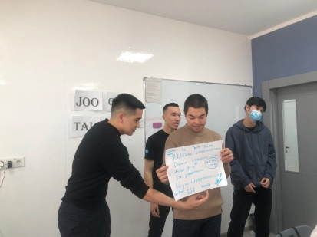 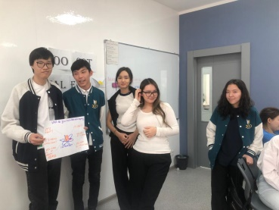 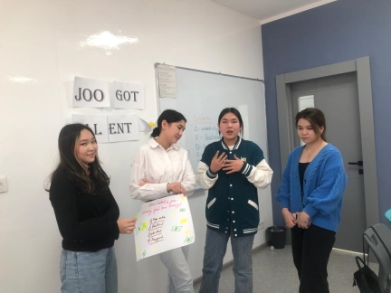

**5. Findings**

Here is the data showing the gradual improvement of students' motivation to learn the language. These charts are based on student interviews and observation papers.

***Diagram 5: Alterations on A learner’s motivation***

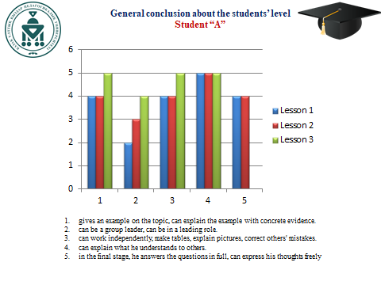

***Diagram 6: Alterations on B learner’s motivation***

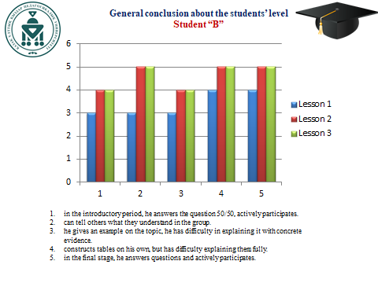

***Diagram 7: Alterations on C learner’s motivation***

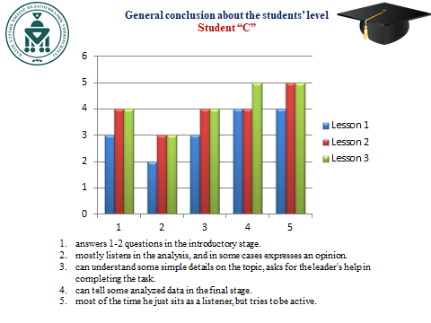

**6. Conclusion and Recommendation**

**6.1 Conclusion**

One thing we noticed when we observed this class was that the group work conducted through the scaffolding strategy helped to increase the cooperation in the class, to increase the enthusiasm and interest of the students in the lesson. Because when working with a group through group work, each person is responsible not only for himself, but for the group. This feature was especially noticeable in the 2nd and 3rd lessons of the research lesson. There was little variation between the expected results of the task and the results obtained, that is, only student A's work completely matched the expected result, while the results of students B and C were completely different from the expected result. As a result of the discussion after the lesson, the reason for the changes in the results of students B and C here was determined. In some tasks it was seen that student B struggled or became less active and student C performed well and struggled in some verbal tasks. Therefore, it can be seen that the impact of Scaffolding was insignificant for student B, but it opened up new opportunities for student C. And for student A, the effect was to be able to work actively with other students during group work, to have friendly relations.

Summing up, during the research, we noticed that students "A", "B", "C" gradually achieved progress in 3 lessons due to the influence of the teacher and the help of students to each other, were able to show some results, and began to be formed by the used strategy and new methods. However, we realized that 3 study lessons would be less to achieve 100% results.

**Reflecting on the use of a scaffolding strategy in lesson study, we can see several advantages:**

Firstly, scaffolding can help teachers to understand the learning needs of their students better. By breaking down complex concepts into smaller, more manageable parts, teachers can gain a deeper understanding of their students' strengths and weaknesses. This knowledge can then be used to inform future lesson planning and instruction.

Secondly, scaffolding can facilitate teacher collaboration. By working together to plan and implement lessons that incorporate scaffolding strategies, teachers can share their expertise and ideas, and learn from one another. This can lead to a more cohesive teaching team, and ultimately, better outcomes for students.

By breaking down complex concepts into smaller, manageable chunks, I was able to better understand the needs of the students in my classroom. More specifically, if I can make it possible for student "A" to work in a group, to improve his relationship with other students, then students "B" and "C" can learn the language by helping each other and solving problems with a common goal. I was able to make it easier and find a solution to their needs to increase their enthusiasm for lessons. However, I have found that careful planning and implementation is essential to ensure that supports are targeted and relevant to the needs of individual students.

In my experience, scaffolding has been found to be a very effective teaching method. For example, the studied "C" allowed the student to rely on his existing knowledge and skills and take risks in learning without fear of failure. This is because this strategy was able to help students gain a deeper understanding of the concepts being taught by breaking them down into smaller chunks.

**6.2 Recommendation**

The study recommends that other colleagues use the scaffolding strategy in their classes. This is because study showed that it is a valuable instructional method that helps learners achieve their goals and develop important skills. By providing temporary support and guidance, scaffolds empower students to take ownership of their learning and reach their full potential. That is, this strategy made it possible to develop the necessary skills to form an independent student and increase his enthusiasm for lessons during the research work.

**Reference**

18 Ways To Scaffold Learning, as Recommended by Teachers (weareteachers.com)

Belland, B. R. (2014). Scaffolding. In Handbook of research on educational communications and technology (pp. 503-514). Springer.

Carolyn M. Evertson Vanderbilt University Carol S. Weinstein Rutgers, HANDBOOK OF CLASSROOM MANAGEMENT, Research, Practice, and Contemporary Issues Edited by The State University of New Jersey

Collins, A., Brown, J. S., & Newman, S. E. (1989). Cognitive apprenticeship: Teaching the crafts of reading, writing, and mathematics. In Knowing, learning, and instruction: Essays in honor of Robert Glaser (pp. 453-494). Lawrence Erlbaum Associates.

Edmund T. Emmer and Edward J. Sabornie, Handbook of Classroom Management Second Edition

Hogan, D., & Pressley, M. (1997). Scaffolding student learning: Instructional approaches and issues. Cambridge University Press.

Lyron Winderbaum, Classroom Management Handbook, April 2, 2018)

Palincsar, A. S., & Brown, A. L. (1984). Reciprocal teaching of comprehension-fostering and comprehension-monitoring activities. Cognition and instruction, 1(2), 117-175.

Pea, R. D. (2004). The social and technological dimensions of scaffolding and related theoretical concepts for learning, education, and human activity. Journal of the Learning Sciences, 13(3), 423-451.

Rogoff, B. (1990). Apprenticeship in thinking: Cognitive development in social context. Oxford University Press.

Rosenshine, B. V. (2012). Principles of instruction: Research-based strategies that all teachers should know. American Educator, 36(1), 12-19.

Van de Pol, J., Volman, M., & Beishuizen, J. (2010). Scaffolding in teacher-student interaction: A decade of research. Educational Psychology Review, 22(3), 271-296.

Vygotsky, L. S. (1978). Mind in society: The development of higher psychological processes. Harvard University Press.

Wood, D., Bruner, J. S., & Ross, G. (1976). The role of tutoring in problem solving. Journal of child psychology and psychiatry, 17(2), 89-100.

Пит Дадли. Lesson Study: руководство, www.lessonstudy.co.uk. 2.

Руководство для учителя, первый (продвинутый) уровень, рекомендовано Методическим советом ЦПМ АОО «Назарбаев Интеллектуальные школы»

Чичибу Т. Lesson Study бойынша мұғалімдерге арналған нұсқаулық: ағылш./Т. Чичибу (Жапония), Л. Ду Тоит (Оңтүстік Африка), А.Тулепбаева (Қазақстан Республикасы). Астана: «Назарбаев Зияткерлік мектептері» ДББҰ Педагогикалық шеберлік орталығы, 2013.

**REFLECTIVE REPORT ON LESSON STUDY**

**“Encouraging students to learn the language by using powerful classroom management strategy”**

Talkanbayeva Kadirgul Mirambekkyzy

Institute of Philology

6B01705 - "Foreign language: two foreign languages"

Department of methods of teaching foreign languages

***Abstract:*** *The paper describes the importance of changing teaching methods to foster student motivation and improve language learning outcomes. The abstract emphasizes the role of classroom management in creating an engaging learning environment where students not only rely on the teacher but also interact with their classmates to enhance their language skills. The study recognizes the presence of students with different educational levels in the class and aims to motivate all students to actively participate in language learning activities. To achieve this goal, the researchers read various classroom management strategies, with a particular focus on the scaffolding strategy. The scaffolding strategy aims to guide students from simpler to more complex tasks, fostering their motivation and enhancing their understanding and perception of the language. Additionally, the abstract mentions the importance of a supportive strategy in lesson study. This strategy involves providing appropriate support and guidance to students to help them acquire new knowledge and skills. The level and type of support may vary depending on factors such as learning objectives, student needs, and task complexity.*

**Keywords:** lesson study, classroom management, scaffolding strategy, group work, analyzing, encouraging, planning, using, education, teaching methodology